**Evidence for Project Unit**

Rachael Ellen E20

**P. 1 Github Contributors page**

Evidence for unit

**P. 2 Project Brief**

Evidence for unit

**P. 3 Use of Trello**

Evidence for unit

**P. 4 Acceptance Criteria**

Evidence for unit

**P. 5 User sitemap**

Evidence for unit

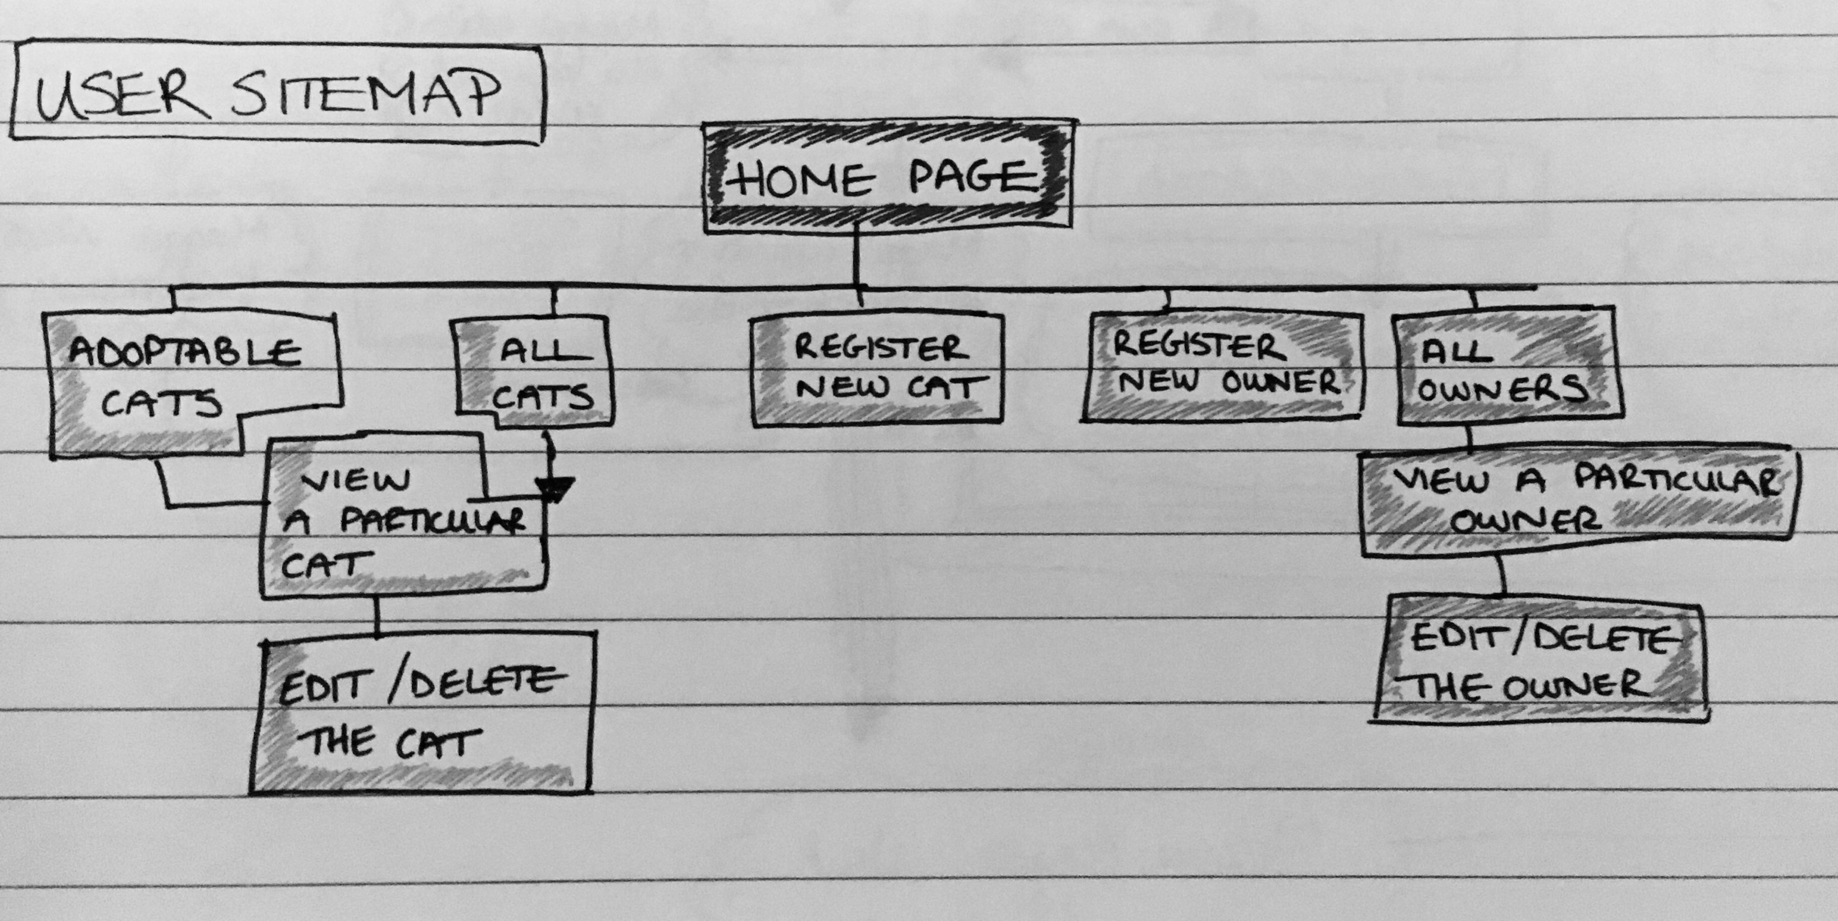

**P. 6 Wireframes designs**

Evidence for unit

Evidence for unit

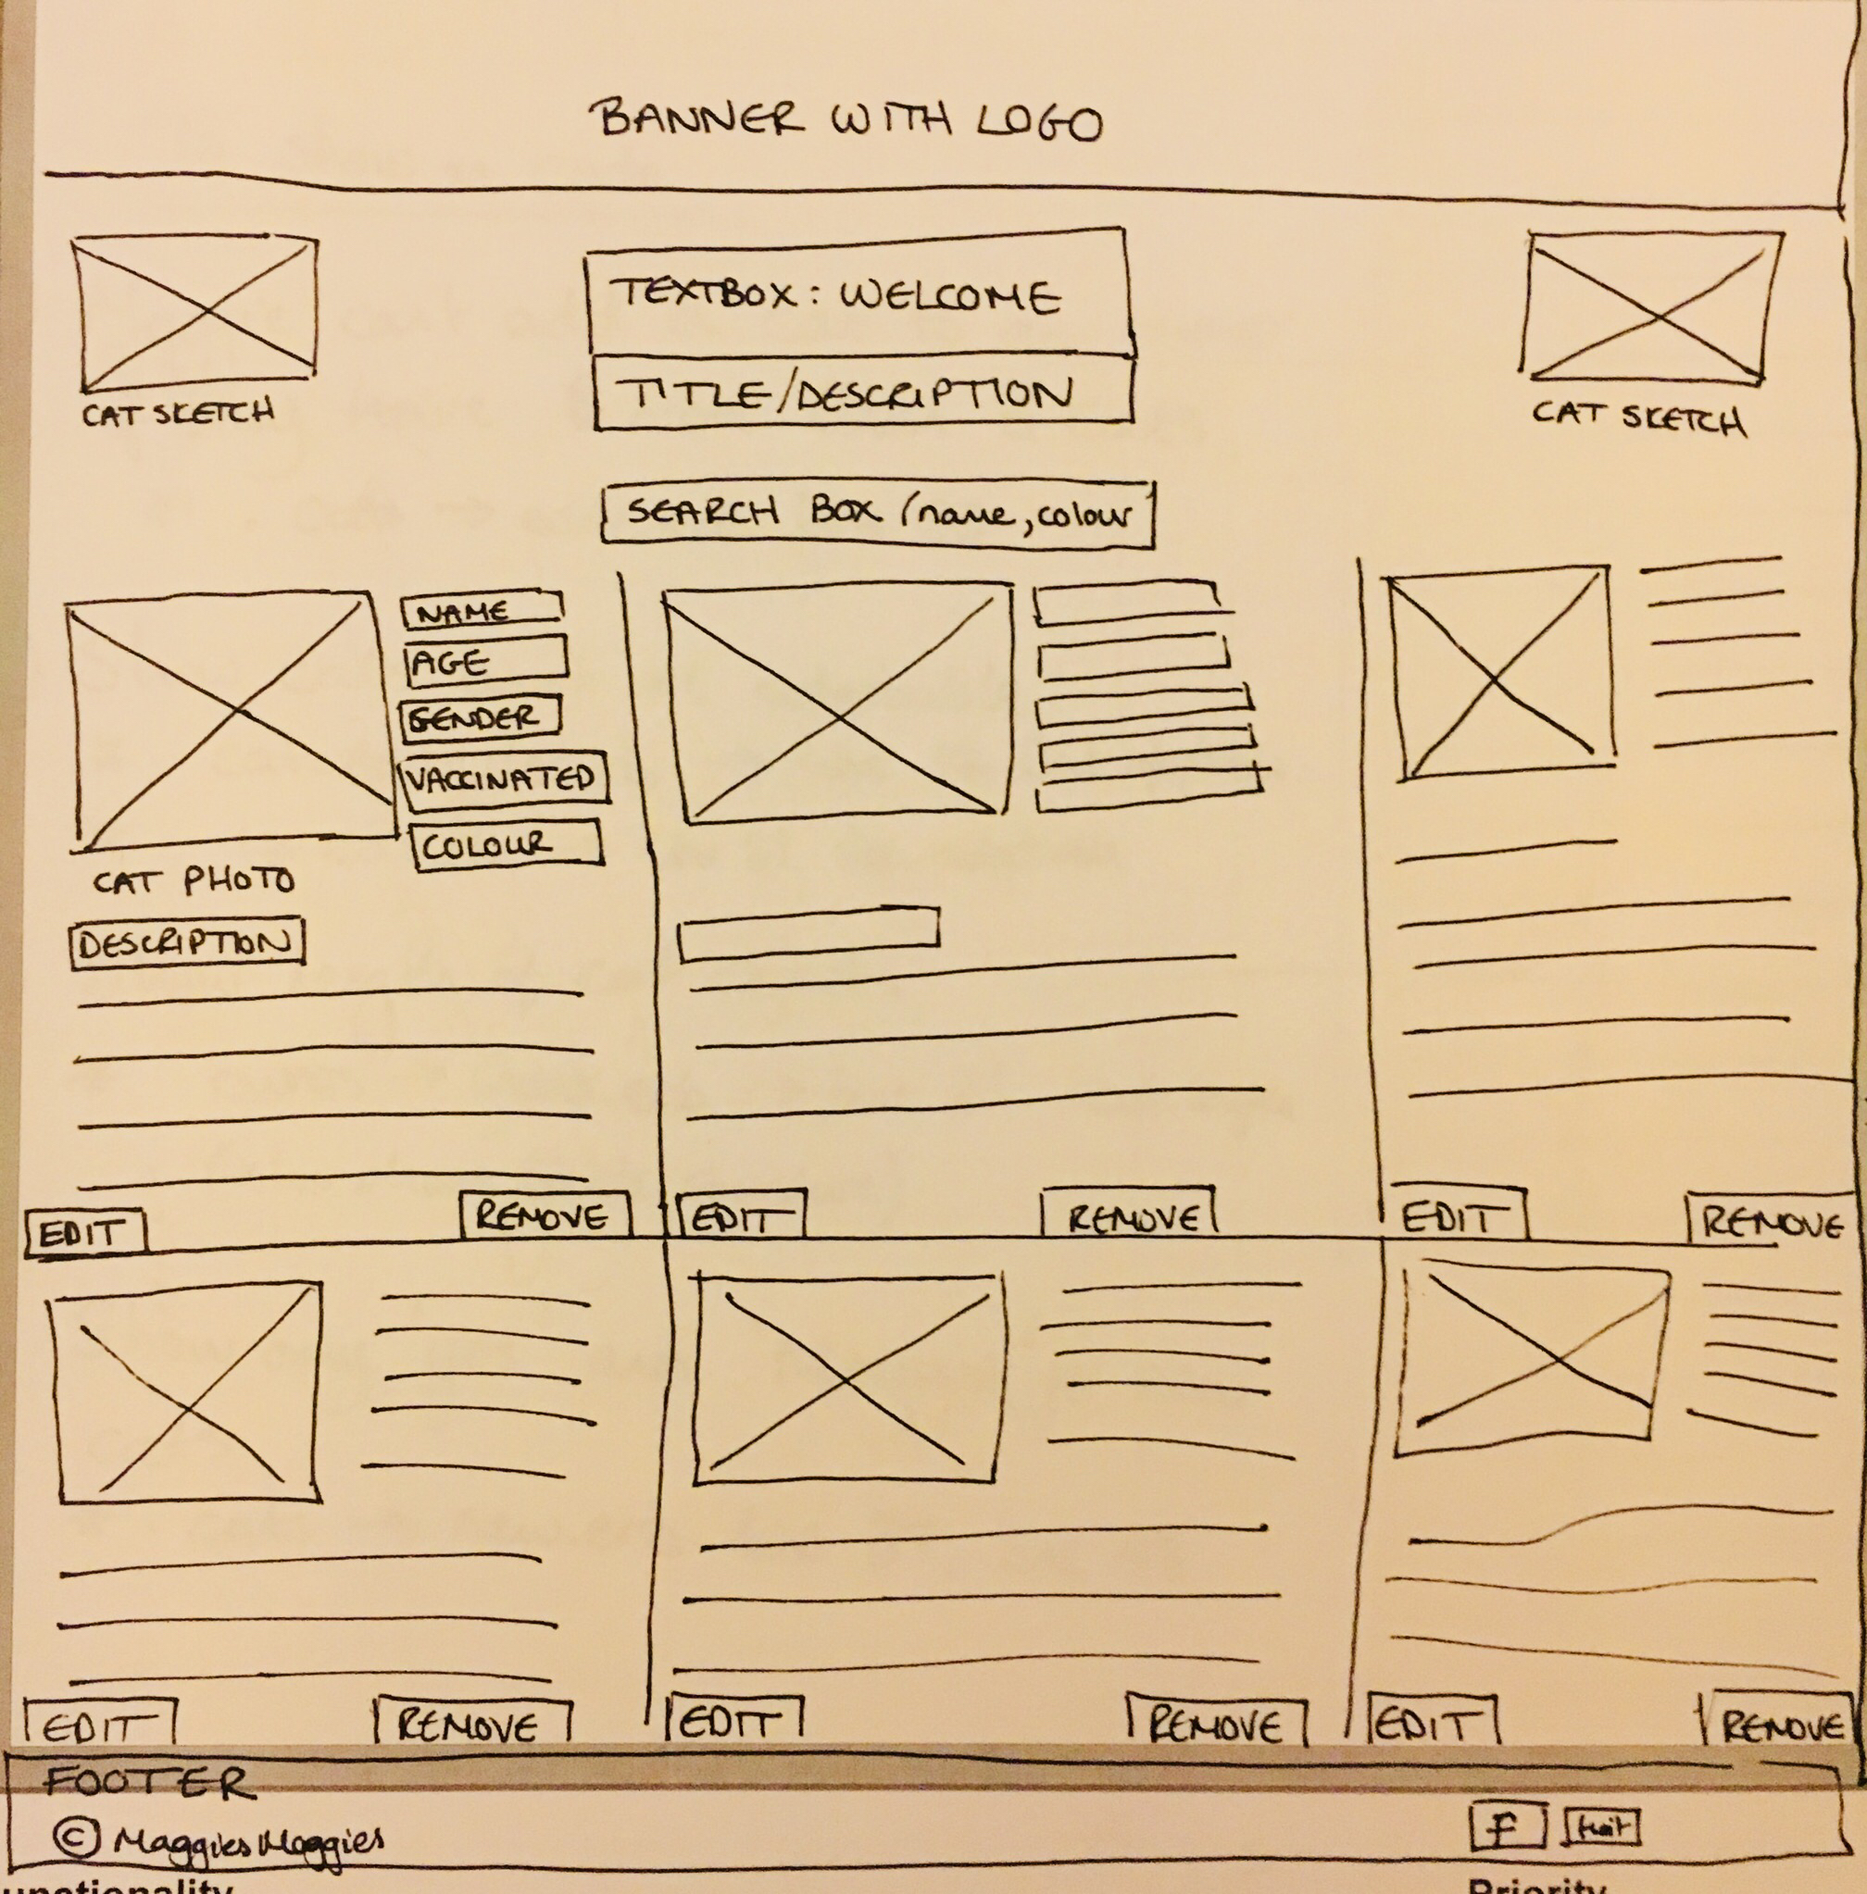

**P. 7 System interactions diagrams**

|  |  |
| --- | --- |
| Evidence for unit | Evidence for unit |

**P. 8 Two Object Diagrams**

Evidence for unit

Evidence for unit

**P. 9 Choice of two algorithms (find the algorithms on a program you might have written, show the code you have used. )**

**On this example please take a screenshot and write what it is doing and why you decided to use it.**

**P. 10 Example of Pseudocode**

Evidence for unit

**P. 11 Github link to one of your projects**

**P. 12 Screenshot of your planning and the different stages of development to show changes.**

Evidence for unit

Evidence for unit

**P. 13 User input**

Evidence for unit

**P. 14 Interaction with data persistence**

**Make sure you show the input being added.**

Evidence for unit

**P. 15 User output result**

Evidence for unit

**P. 16 Bug tracking report showing the errors diagnosed and corrected.**

Evidence for unit

**P. 17 Testing your program**

**Show the test code, the test not passing.....and then the test fixed.**

Evidence for unit